**SAP BW/BO Exercise**

**Exercise 13: Crystal Report Dashboard Design**

**Student Name: Manish Bordoloi Student Id: 2021244262**

**Date: 08/05/2015 SAP ERP Login Id: M5UTD-005**

**Task 1: Create a new SAP Crystal Dashboard Design project and import a spreadsheet**

Short description: You create a new SAP Crystal Dashboard Design project that is based on an existing spreadsheet including the global sales data.

1. Start SAP Crystal Dashboard Design (Xcelsius):

**Start → Programs → Dashboard 4 → Dashboards.**

1. You are going to use an existing spreadsheet model. Therefore you have to import the spreadsheet model *DataSet.xls* into SAP Crystal Dashboard Design. Your lecturer will provide this spreadsheet.

**Data → Import → Confirm pop-up in case you are asked if you want to continue → Select excel file *DataSet.xls* → Open**

The sales data is now available in the embedded spreadsheet of SAP Crystal Dashboard Design:

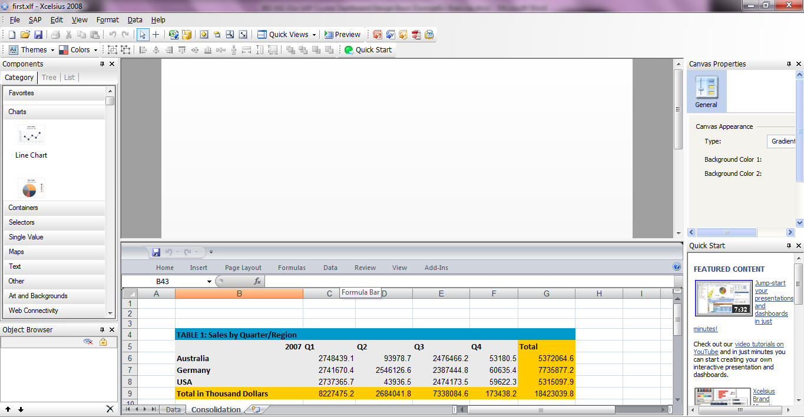

1. Save the SAP Crystal Dashboard Design project on your desktop.

**File** → **Save as** →**SalesOverview_XX.xlf (XX being your ID)**

**Task 2: Create headline and a column chart for sales by quarter/region**

1. At first, you create a headline for your dashboard. On the **Components panel** (on the left), select the tree view and drag a label component to the top left corner of the canvas.

**Components panel** → **Select tree view** → **Text** → **Label**

Double click on the label to open the **Properties panel** on the right most of the sheet. On the **General tab** enter “*Global Sales Overview*” as text. On the **Appearance - Text tab**, change the font size for text to *20 pt*.

For an easier maintenance of your dashboard you should assign individual names to your components. Therefore go to the **Object browser** (Left bottom) and rename the label component from *Label 1* to *dashboard_title*.

**Object browser** → **single-click on** *Lable 1*→ **open context menu (right mouse click)** → **rename** → **enter** *dashboard_title* ***as new name***

1. You want to change the background color of the canvas. Double click on an empty area in the canvas to open the **Properties panel** for the canvas. On the **General tab** set the background color of the canvas to *white*.

1. Now you add the first chart to your dashboard. On the **Components panel**, select the tree view and drag a column chart to the upper left corner of the canvas.

**Components panel** → **Select tree view** → **Chart** → **Column Chart**

1. Double click on the column chart to open the **Properties panel**. You have to configure the following tabs:
   1. Properties panel: General
   2. Properties panel: Behavior - Scale
   3. Properties panel: Appearance - Color

Configure these tabs as shown below.

* + 1. Properties Panel: General

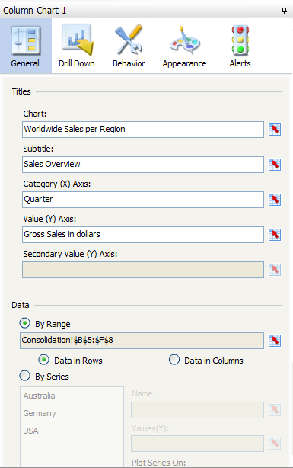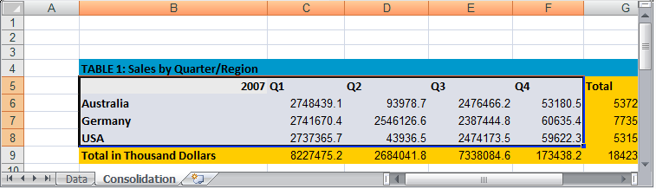

**Properties Panel: behavior - Scale Properties Panel: Appearance - Color**

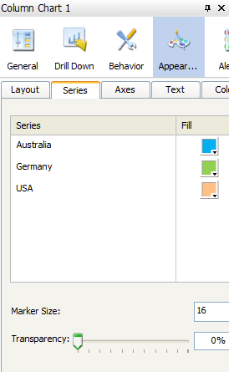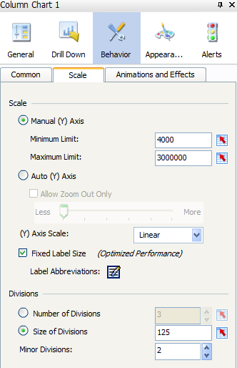Go to the **Object browser** and rename the column chart to sales per region.

1. Save  your changes and run the preview  to check your dashboard.

NOTE: If you receive a message saying "your range has been reduced to maximum rows allowed”, then go to File->Preferences->Excel Options and increase the maximum number of rows to (say 2000).

You can see that your excel sheet has 1081 rows. Select the rows after 1081 till the end of the spreadsheet and right click and clear contents. The idea is to delete any unnecessary content in the Excel sheet so that our data is within the maximum number of rows allowed.

**Question1. Paste the screenshot of the dashboard.**

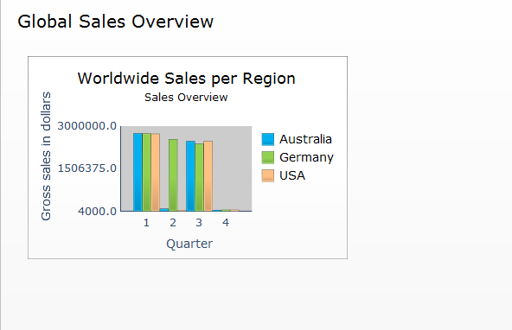

Click on Preview again to go back to the previous screen.

**Task 3: Create a column chart for CY/PY comparison by region**

1. Now you add a further column chart to your dashboard. On the **Components panel**, select the tree view and drag a column chart to the upper right corner of the canvas.

**Components panel** → **Select tree view** → **Chart** → **Column Chart**

Double click on the column chart to open the **Properties panel**.

You have to configure the following tabs:

* 1. Properties panel: General
  2. Properties panel: Behavior – Scale
  3. Properties panel: Appearance – Color

Configure the properties as shown below.

1. **Properties Panel: General**

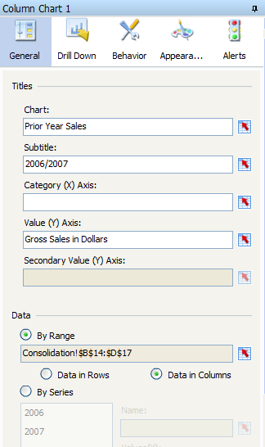

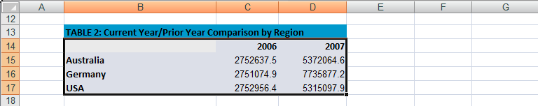

**b) Properties panel: Behavior – Scale c) Properties panel: Appearance – Color**

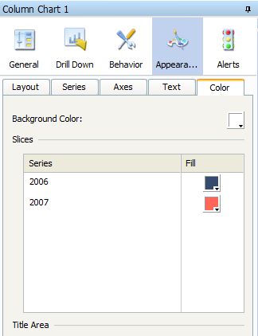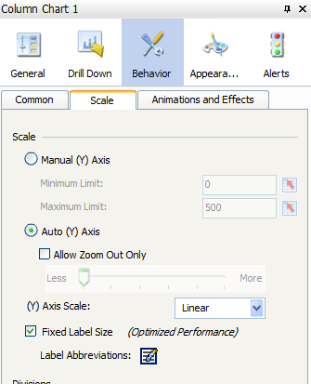

Go to the **Object browser** and rename the column chart to *py_cy_comparison*.

1. Save  your changes and run the preview  to check your dashboard.

**Question2. Paste the screenshot of the dashboard.**

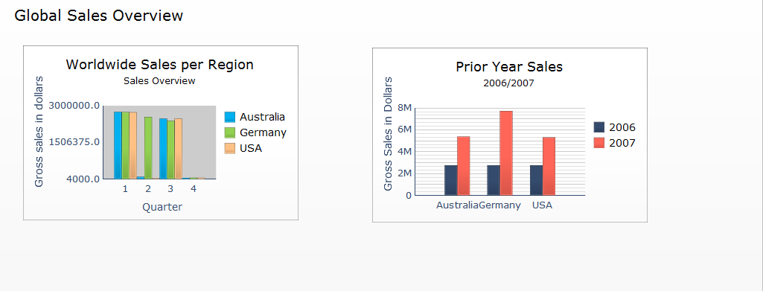

**Task 4: Create a pie chart that shows the share of each product group**

1. For this scenario you have to add a pie chart and a radio button to your dashboard. On the **Components panel**, select the tree view and drag a pie chart and a radio button selector to the canvas.

**Components panel** → **Select tree view** → **Chart** → **Pie Chart**

**Components panel** → **Select tree view** → **Selectors** → **Radio Button**

First, you configure the properties of the selector component. Double click on the radio button selector to open the **Properties panel**.

Configure the properties as shown below:

**Properties Panel: General**

Note the labels can be applied using a data series in your spreadsheet model or by manually adding the labels with the position indicators.

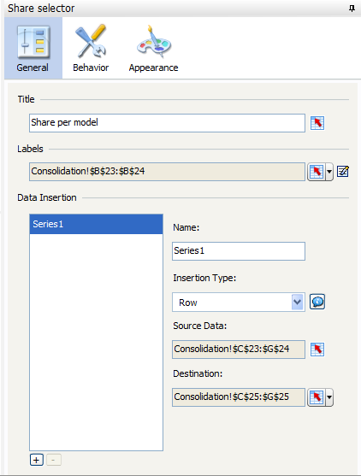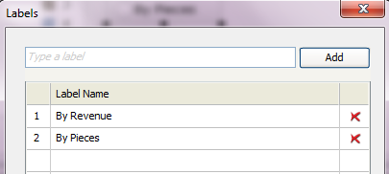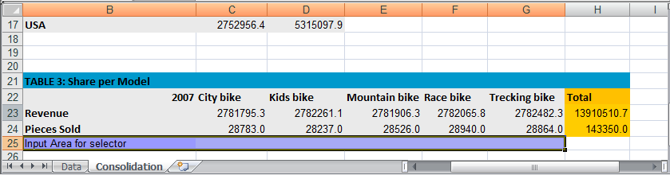

Now double click on the pie chart to open the **Properties panel**.

Configure the properties as shown below:

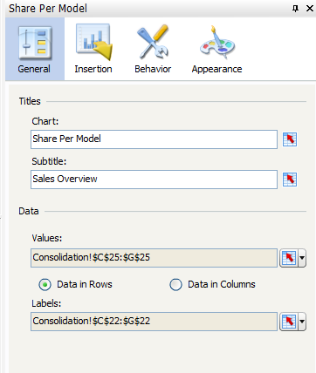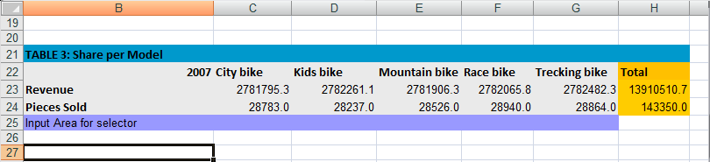

1. Go to the **Object browser** and rename the pie chart to *share per model,* rename the radio button selector *to share selector*.
2. A grey rectangle should serve as underlying frame for the pie chart and its selector. On the **Components panel**, select the tree view and drag a rectangle to the canvas.

**Components panel** → **Select tree view** → **Art and Backgrounds** → **Rectangle**

Go to the **Object browser** and rename the rectangle to *share_frame*.

Set a grey color for the rectangle. Configure the rectangles properties as shown below:

1. As the rectangle serves as a new frame for the chart, hide the frame and background of the pie chart. To do so, you have to deactivate the “Show Chart Background” option in the pie chart’s properties.

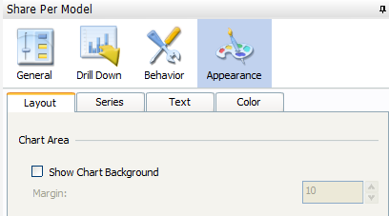

1. Save  your changes and run the preview  to check your dashboard.

The pie chart and its selector component should look as follows:

**Question3. Paste the screenshot of the dashboard.**

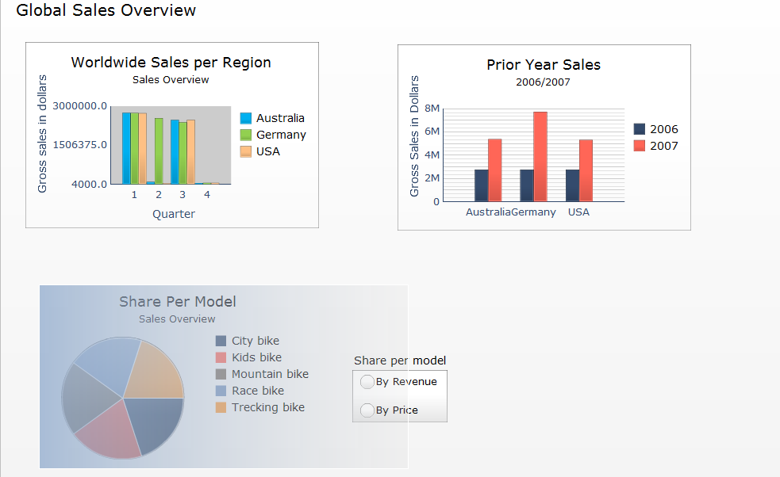

**Task 5: Add the KPIs Market Share, Profit Margin and Pieces Sold to your dashboard, and group them using a container component**

1. Now you add a container including the three major global KPIs. On the **Components panel**, select the tree view and drag a panel container to the right side of the canvas. In case you do not have enough space on the right side you might have to resize your existing charts. Add three gauges to the panel container.

**Components panel** → **Select tree view** → **Containers** → **Panel container**

**Components panel** → **Select tree view** → **Single Value** → **Gauge** → **Gauge**

1. Go to the **Object browser** and rename the components as follows:

- Panel Container: KPI_container

- Gauge 1: KPI_pieces_sold

- Gauge 2: KPI_market_share

- Gauge 3: KPI_profit_margin.

1. Double click on the panel container and assign the title “Worldwide KPIs” in the general tab of the **Properties panel.**
2. Configure the properties of the three gauges as shown below:

**Gauge “Pieces Sold” (Data from TABLE3)**

**Properties Panel: General Properties Panel: Alerts**

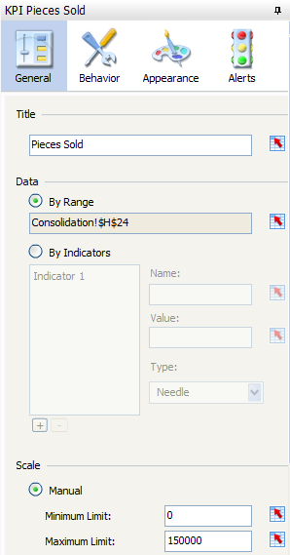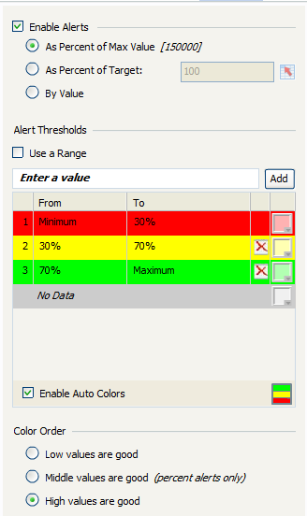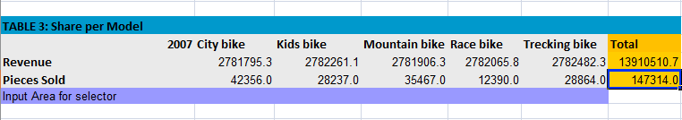

**Gauge “Market Share” (Data from TABLE4)**

**Properties Panel: General Properties Panel: Alerts**

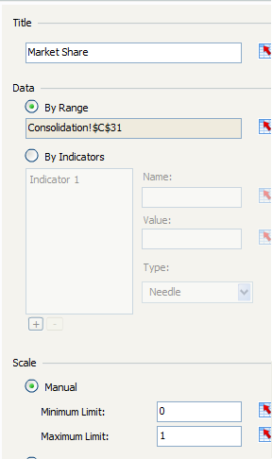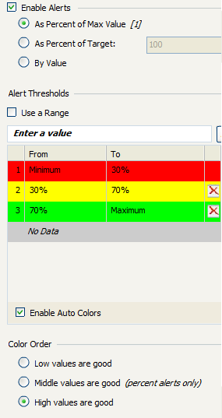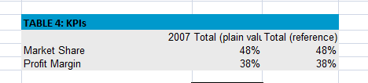

**Gauge “****Profit Margin” (Data from TABLE4)**

**Properties Panel: General Properties Panel: Alerts**

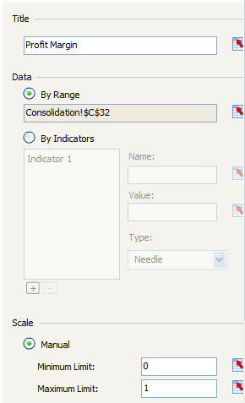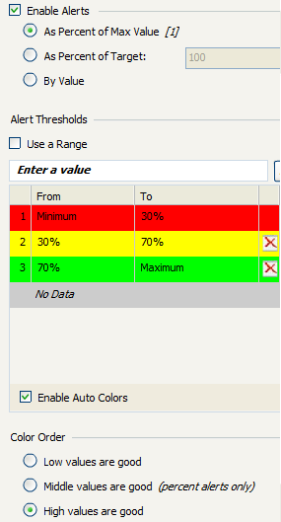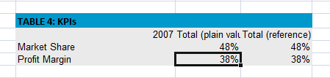

1. Save  your changes and run the preview  to check your dashboard.
2. You want to adjust the layout for the gauges’ values shown in the bottom of each gauge. Customize the appearance of the value for all three gauges in a way that is suitable for the layout

**Double click on gauge** → **Properties panel** → **Appearance** → **Text** → **Select ‘value’** → **Change font formatting**

1. Save  your changes and run the preview  to check your dashboard.

**Question4. Paste the screenshot of the dashboard.**

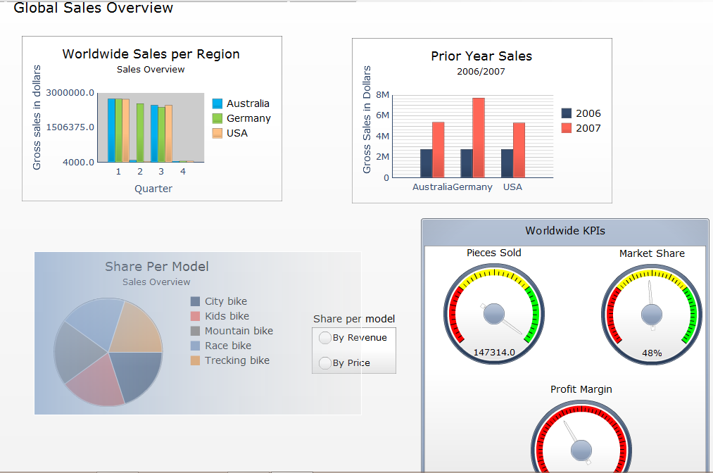

**Task 6: Export your dashboard into PDF**

1. **File → Export → Export to pdf**
2. Open the PDF document and check your dashboard.
3. Submit your word and pdf files.